**Database Joins:**

* Inner Join
* Left Outer Join
* Right Outer Join
* Full Outer Join

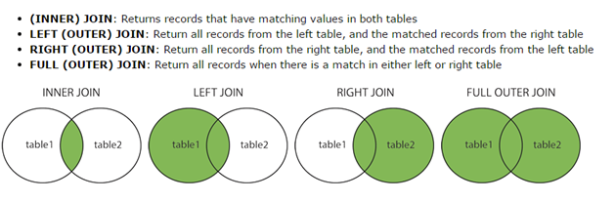

To illustrate various joins, we created three tables - Customers, Employees and Orders. Please review the following and understand the concepts in joining the tables.

**IMPORTANT:**

You need this knowledge in Tableau to join the data from various sources

**Customers:**

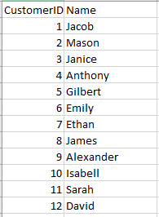

**Employees:**

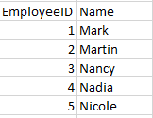

**Orders:**

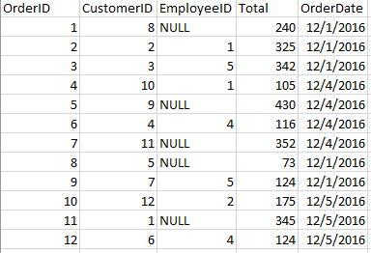

**Inner Join:**

Display the data for Customers who have orders: CustomerID, Name, OrderID, Total

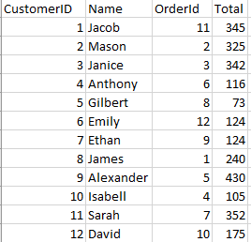

**Left Outer Join:**

Display the Orders whether any employees associated with the orders or not

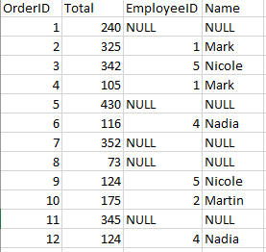

**Right Outer Join:**

Display all the employees whether they are associated with any orders or not

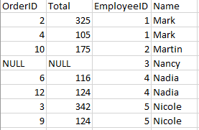

**Full Outer Join:**

Display all the Orders and all the Employees – even when employees are not associated with any orders and any employee who has not taken any orders

